NVIDIA FINANCIAL REPORT
Manish Babu Palakurti, Naga Nandha Kambhampati
NVIDIA Corporation is the worldwide leader in visual computing technologies and the inventor of the graphic processing unit, or GPU. Over the years, the company's focus has evolved from PC graphics to artificial intelligence (AI) based solutions that now support high performance computing (HPC), gaming and virtual reality (VR) platforms. NVIDIA’s GPU success can be attributed to its parallel processing capabilities supported by thousands of computing cores, which are necessary to run deep learning algorithms. The company's GPU platforms are playing a major role in developing multi-billion-dollar end-markets like robotics and self-driving vehicles. NVIDIA is a dominant name in the Data Centre, professional visualization and gaming markets where Intel and Advanced Micro Devices are playing a catch-up role. The company's partnership with almost all major cloud service providers (CSPs) and server vendors is a key catalyst.
Revenue:
NVIDIA annual revenue history and growth rate from 2015 to 2024. Revenue can be defined as the amount of money a company receives from its customers in exchange for the sales of goods or services. Revenue is the top line item on an income statement from which all costs and expenses are subtracted to arrive at net income.
- NVIDIA revenue for the quarter ending October 31, 2024 was $35.082B, a 93.61% increase year-over-year.
- NVIDIA revenue for the twelve months ending October 31, 2024 was $113.269B, a 152.44% increase year-over-year.
- NVIDIA annual revenue for 2024 was $60.922B, a 125.85% increase from 2023.
- NVIDIA annual revenue for 2023 was $26.974B, a 0.22% increase from 2022.
- NVIDIA annual revenue for 2022 was $26.914B, a 61.4% increase from 2021.

Gross Profit:
NVIDIA annual gross profit history and growth rate from 2010 to 2024. Gross profit can be defined as the profit a company makes after deducting the variable costs directly associated with making and selling its products or providing its services.
- NVIDIA gross profit for the quarter ending October 31, 2024, was $26.156B, a 95.19% increase year-over-year.
- NVIDIA gross profit for the twelve months ending October 31, 2024, was $85.927B, a 174.15% increase year-over-year.
- NVIDIA annual gross profit for 2024 was $44.301B, a 188.49% increase from 2023.
- NVIDIA annual gross profit for 2023 was $15.356B, a 12.13% decline from 2022.
- NVIDIA annual gross profit for 2022 was $17.475B, a 68.09% increase from 2021.

Operating Income
NVIDIA annual operating income history and growth rate from 2010 to 2024. Operating income can be defined as income after operating expenses have been deducted and before interest payments and taxes have been deducted.
- NVIDIA operating income for the quarter ending October 31, 2024, was $21.869B, a 109.94% increase year-over-year.
- NVIDIA operating income for the twelve months ending October 31, 2024, was $71.035B, a 244.61% increase year-over-year.
- NVIDIA annual operating income for 2024 was $32.972B, a 680.59% increase from 2023.
- NVIDIA annual operating income for 2023 was $4.224B, a 57.93% decline from 2022.
- NVIDIA annual operating income for 2022 was $10.041B, a 121.56% increase from 2021.

Net Income:
NVIDIA annual/quarterly net income history and growth rate from 2010 to 2024. Net income can be defined as company's net profit or loss after all revenues, income items, and expenses have been accounted for.
- NVIDIA net income for the quarter ending October 31, 2024 was $19.309B, a 108.9% increase year-over-year.
- NVIDIA net income for the twelve months ending October 31, 2024 was $63.075B, a 233.94% increase year-over-year.
- NVIDIA annual net income for 2024 was $29.76B, a 581.32% increase from 2023.
- NVIDIA annual net income for 2023 was $4.368B, a 55.21% decline from 2022.
- NVIDIA annual net income for 2022 was $9.752B, a 125.12% increase from 2021.
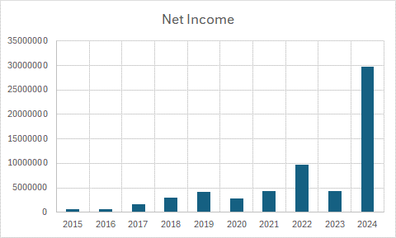

Total Asserts:
NVIDIA total assets from 2010 to 2024. Total assets can be defined as the sum of all assets on a company's balance sheet.
- NVIDIA total assets for the quarter ending October 31, 2024, were $96.013B, a 77.32% increase year-over-year.
- NVIDIA total assets for 2024 were $65.728B, a 59.6% increase from 2023.
- NVIDIA total assets for 2023 were $41.182B, a 6.8% decline from 2022.
- NVIDIA total assets for 2022 were $44.187B, a 53.48% increase from 2021.

